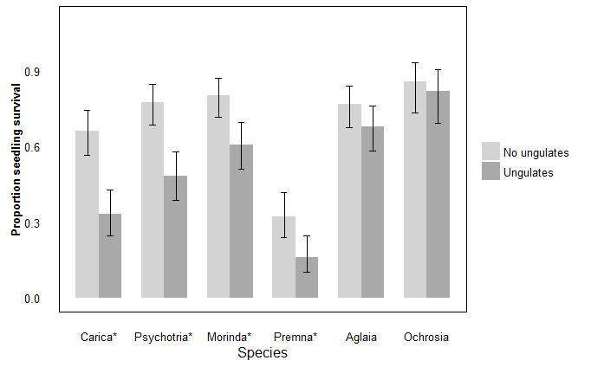

Figure 1. A higher proportion of seedlings remained alive in fenced versus unfenced plots for four out of six forest species. For *Carica papaya*, *Morinda citrifolia*, *Psychotria mariana*, and *Premna obtusifolia*, all indicated with \*, the best fit model for proportion alive included treatment, and in all cases, proportion alive inside fenced plots with “No ungulates” was higher than outside fenced plots with “Ungulates.” For *Aglaia mariannensis* and *Ochrosia oppositifolia* seedlings, treatment did not contribute to the best fit model explaining proportion of seedlings alive, and proportion of seedlings alive did not differ significantly due to treatment.

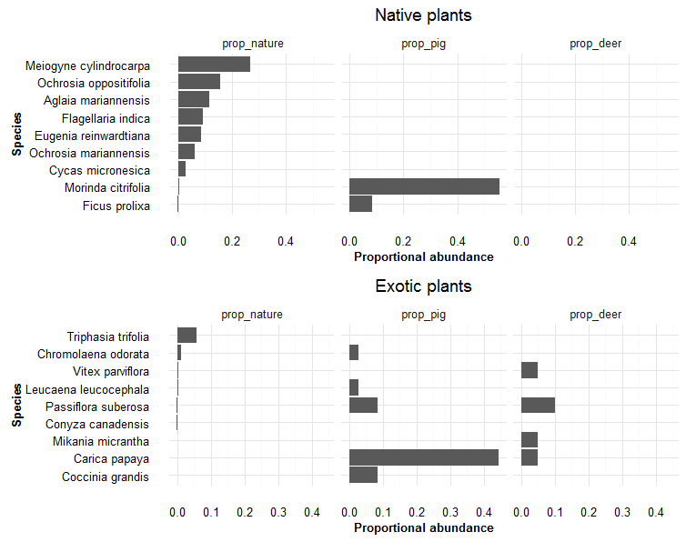

Figure 2. Proportional abundance of species in nature, with most abundant at the top, are shown in the left most panel of each bar graph for native and exotic species, in the top and bottom panels, respectively. Top panel shows the most abundant native fruiting species in nature in, based on vegetation surveys, with *Meiogyne* *cylindrocarpa* to *Cycas* *micronesica* being the seven most abundant species counted on transects. *Morinda* *citrifolia* and *Ficus* *prolixa*, while not part of the most abundant species on vegetation transects, were two native species that germinated from pig scats more commonly than how commonly they were found in nature. Exotic species, especially Carica papaya and Coccinia grandis, also germinated in a relatively high proportion of scats, given their relatively low availability in nature. The two right-hand panels show that no native species germinated from deer scats. Instead a small number of exotic species germinated in just a few scats.

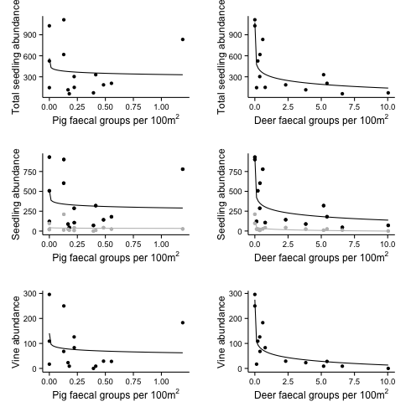

Figure 3. In the left-hand column, regression analysis between abundance of pig faecal groups (relative index for population abundance) showed no relationship with total seedling abundance, exotic nor native seedling abundance (middle row, with black line for native and gray line for exotic), nor vine abundance per survey site in Guam. In the right hand column, abundance of deer faecal groups (relative index for population abundance) show strong negative loglinear relationships to total seedling abundance (R2 = 0.710), native seedling abundance (R2 = 0.647), exotic seedling abundance (R2 = 0.696), and to vine abundance (R2 = 0.751).